U.S. National Science Foundation
Convergence Accelerator 2023 Cohort
Phase 2, Year 1 Reverse Site Visit
Virridy Convergence Accelerator Team Report, March 24, 2025

Track | Future Water Systems
Phase 2 Award Number | 24C0011
Project Title | Measuring and Mitigating Land Management Impacts on Water Quality and Climate through Convergent Sensing, Machine Learning, Carbon Markets, and Policy
Principal Investigator | Evan Thomas
Lead Institution | SweetSense Inc. (dba Virridy)
Cohort Solicitation | NSF 23-590 / NSFBAA-CA23-01

Project Overview
Water-quality impairment across the United States and globally is driven largely by diffuse watershed processes rather than point-source discharges alone. Nonpoint source pollution originating from agriculture, land-use change, sediment transport, and hydrologic variability remains difficult to regulate because it is spatially distributed, episodic, and behaviorally mediated. This project addresses that challenge through an integrated convergence framework combining continuous environmental sensing, machine learning analytics, regulatory co-design, and climate-finance mechanisms. The approach is designed not only to measure environmental conditions but to change infrastructure decision-making by quantifying the environmental, economic, and public-health consequences of alternative compliance pathways.
The project integrates two core components that reinforce each other: first, a real-time environmental sensing and modeling platform—the Virridy Lume—capable of continuous in-situ measurement of tryptophan-like fluorescence (TLF), chlorophyll-a, and fluorescent dissolved organic matter (FDOM) to attribute water-quality outcomes to watershed activities; and second, a finance and policy architecture that converts verified environmental improvements into revenue streams capable of funding restoration and management interventions. The Lume platform operates autonomously with up to one year of battery life, requires no regular calibration or cleaning, and reports data via cellular and satellite networks at configurable intervals from 30 seconds to 24 hours. This combined system enables watershed-scale adaptive management in which distributed land-based actions substitute for capital-intensive gray infrastructure while maintaining regulatory compliance.
The project currently operates across nine countries—the United States, Rwanda, Burundi, Democratic Republic of Congo, Madagascar, Kenya, Tanzania, Turkey, and France—with programs spanning drinking water treatment, precision irrigation, and watershed restoration. Carbon credits are generated and verified under Gold Standard, Verra VCS (VM0042), and Regen Registry methodologies, with projections of over 3 million credits and 5 million people reached by 2030.

Intellectual Merit
The intellectual merit of this project lies in its development of a unified scientific and institutional framework linking environmental measurement, predictive modeling, infrastructure planning, and carbon accounting. The work advances fundamental understanding of how infrastructure decision pathways influence long-term environmental and climate outcomes, particularly emissions embedded in water treatment systems. Avoiding construction of energy- and chemical-intensive infrastructure can eliminate decades of emissions at once, reframing environmental mitigation as a question of system design rather than only operational efficiency.
The sensing component advances environmental monitoring science through development of autonomous fluorescence instrumentation—the first single-unit fluorimetric sensor for continuous microbial water quality monitoring—capable of measuring tryptophan-like fluorescence at 280/350 nm excitation/emission, chlorophyll-a at 470/680 nm, and FDOM at 365/480 nm, with integrated turbidity and temperature compensation. The Lume employs a Silicon Photomultiplier (SiPM) detector, achieving near-photomultiplier-tube sensitivity at chip scale. No competing water quality sensor uses SiPM technology. Compared to the photodiode detectors used in all competing TLF instruments, the SiPM provides 12,000 times greater responsivity, 29,000 times better minimum detectable power, and over 100,000 times greater internal gain, while maintaining a detector cost of approximately $130 compared to $4,000 for conventional PMTs. This represents a genuine first-mover technical moat, as photodiode-based TLF sensors are fundamentally limited to approximately 3 ppb limit of detection. Under controlled laboratory conditions, the system reproducibly demonstrated sub-ppb sensitivity that exceeds the stated detection limits of many commercially available TLF instruments. These results are supported by a submitted manuscript (Knopp et al., 2026, EarthArXiv) and build on prior peer-reviewed work including Bedell et al. (2022, Water Research). The underlying sensing approach is protected by U.S. Patent 11,506,606 (Alarm Threshold Microbial Fluorimeter) and supported by three additional granted patents and one pending patent application.
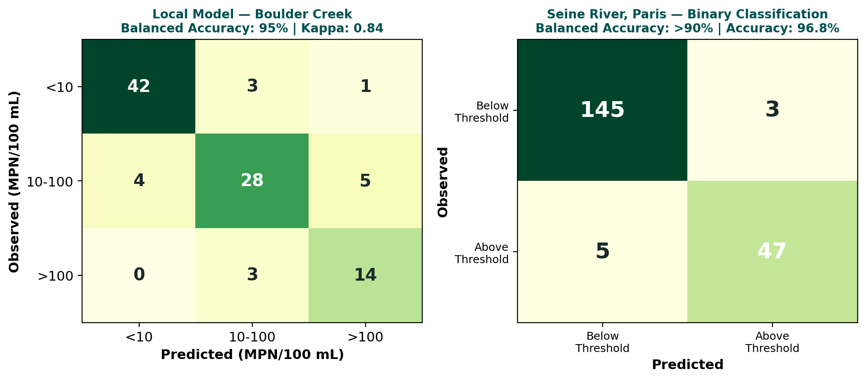
Figure 1. Sensor validation results. Left: Three-category E. coli classification on Boulder Creek test data (balanced accuracy 95%, Cohen’s kappa 0.84). Right: Binary classification on the Seine River, Paris (balanced accuracy >90%, overall accuracy 96.8%).
Field deployments showed strong agreement between sensor-derived Escherichia coli estimates and laboratory Colilert measurements. Approximately 75% of predictions fell within analytical uncertainty bounds of Colilert with 7% MAPE in log-transformed concentration space. With site-specific calibration, categorical accuracy exceeds 94% across 0–1,000 CFU/100 mL. A global model demonstrated approximately 23% MAPE in log space.
A second intellectual contribution lies in life-cycle accounting frameworks that quantify emissions avoided through infrastructure substitution. Attributional life-cycle assessment of a watershed adaptive management program demonstrated verified avoided emissions of 24,143 tCO2e for 2017–2022 and projected approximately 73,463 tCO2e net avoided emissions over 2017–2036 (Demaree et al., 2026, ES&T Water).
A third contribution is the integration of policy design, behavioral science, and market mechanisms into environmental engineering research. Comparative analysis of water-quality trading programs across multiple states demonstrates that institutional clarity, enforceability, and financial viability are primary determinants of implementation success.

Broader Impacts
The project produces measurable environmental, societal, economic, and public-health benefits across multiple geographic contexts. Peer-reviewed randomized controlled trials of the project’s water treatment programs have demonstrated 29–49% reductions in childhood diarrhea, with a cost-benefit ratio of 5.6x across health, livelihood, and environmental dimensions.
In Africa, carbon-financed water programs currently reach over 300,000 children in 350 schools in Rwanda, with additional programs in Burundi (300,000+ people by 2026), Democratic Republic of Congo (80,000 currently served), Madagascar (350,000 by 2030), Kenya (up to 3 million students through the LifeStraw school program; handpump repair time reduced from 214 to 26 days under the $35M USAID DRIP initiative), and Tanzania (approximately 100,000 credits recently purchased from Water Mission). In Turkey, precision irrigation programs cover over 1,000 hectares, reducing emissions by 3.5 tCO2e/hectare annually. In Wisconsin, the Yahara WINS program across 139,000 hectares produced the first-ever verified watershed carbon credit issuance with over 73,000 tonnes CO2e avoided.
The Lume’s economic model also advances accessibility. Conventional grab-sample testing using IDEXX Colilert costs approximately $19 in consumables plus technician labor and vehicle costs per sample, with 18–24 hour time to result. At typical monitoring frequencies of four samples per month across ten sites, grab sampling generates only 40 data points monthly. The Lume provides 720 readings per month per site at $200/month—a 180-fold increase in temporal resolution at comparable or lower cost per site, while capturing transient contamination events that weekly sampling misses entirely. This positions the Lume as a complement to regulatory lab methods, providing continuous real-time screening between periodic confirmatory samples.
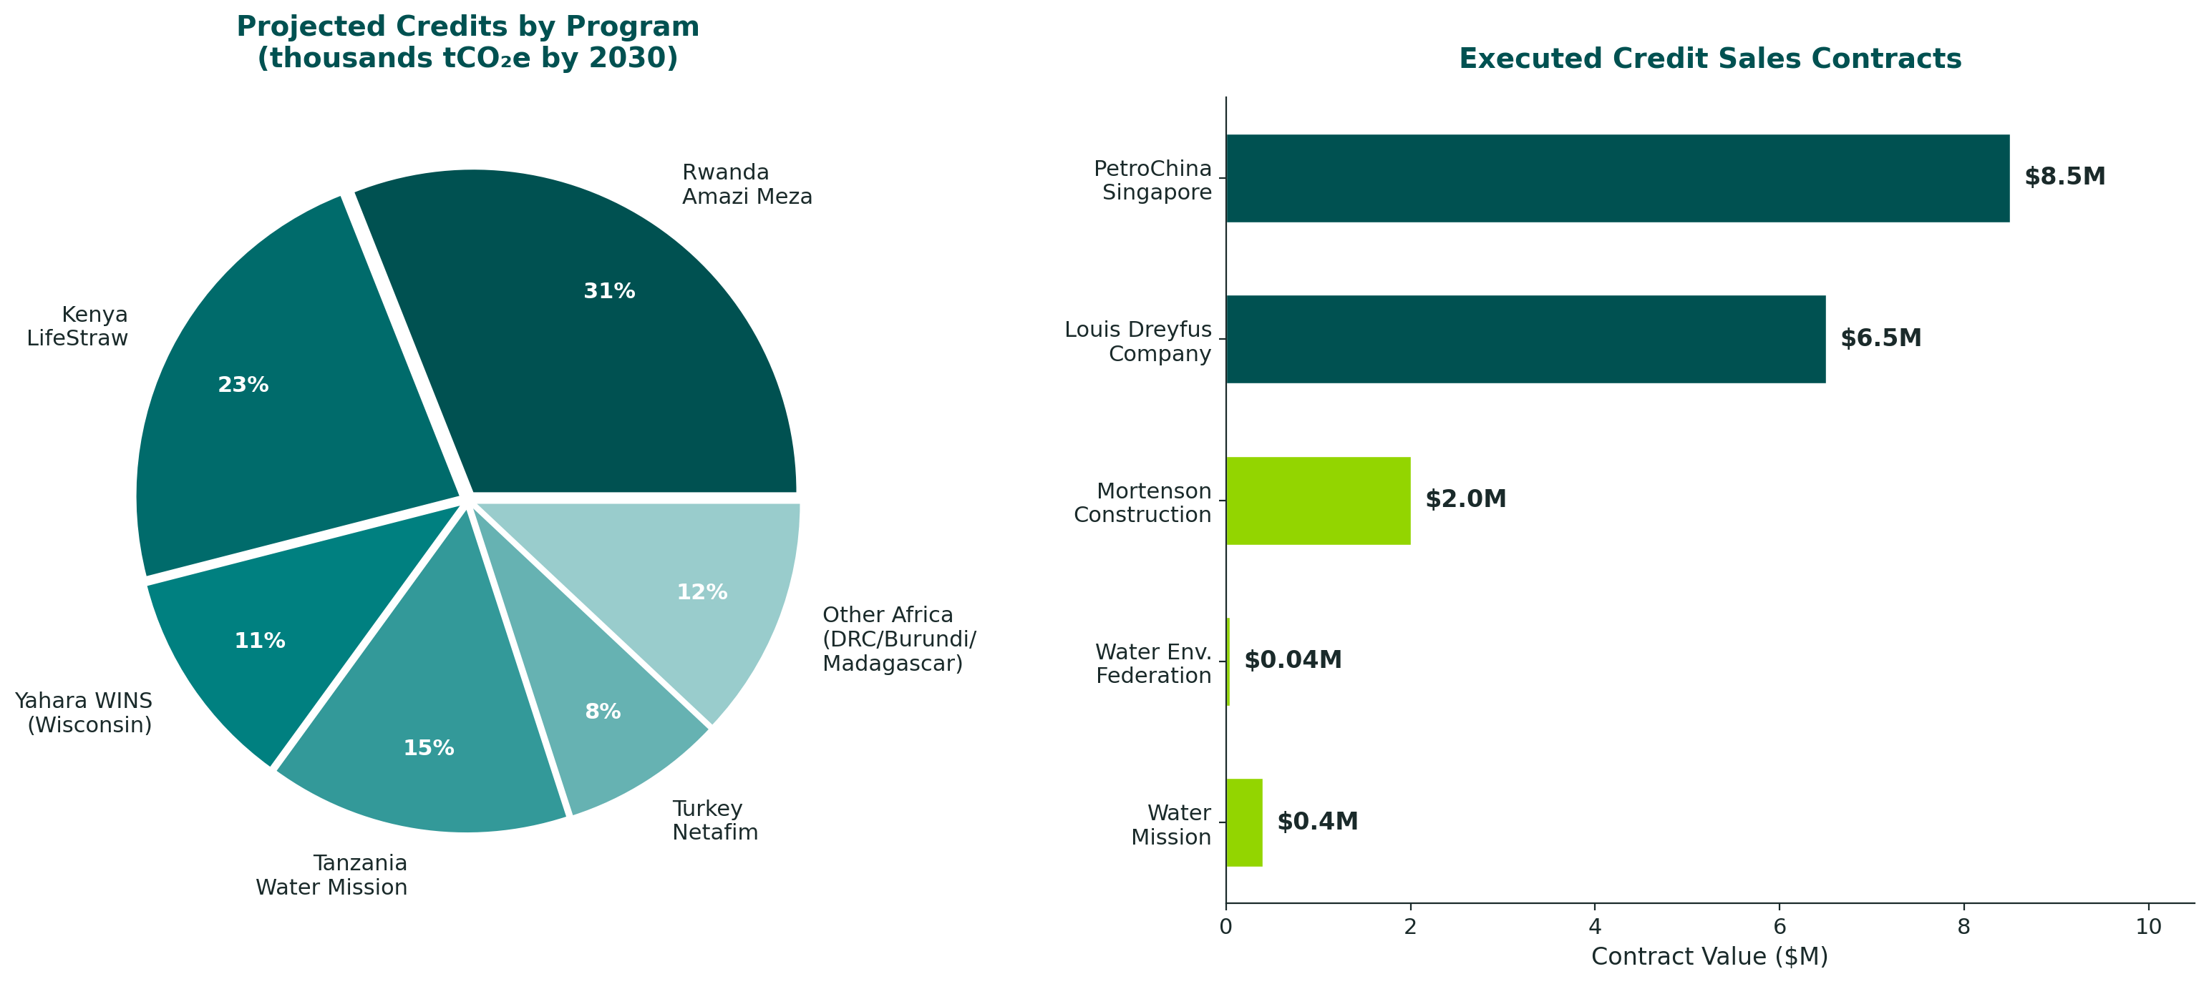
Figure 2. Left: Projected carbon credit generation by program (thousands tCO2e by 2030), with verified issuances to date totaling 78,103 tCO2e. Right: Executed credit sales contracts by buyer, totaling approximately $18M.
The project produces large-scale scientific infrastructure including a global E. coli database exceeding 10 million bacterial coliform observations and 39 peer-reviewed publications in journals including The Lancet Planetary Health, Nature, Science of the Total Environment, Water Research, and ES&T Water. Four granted U.S. patents and one pending patent application protect the core intellectual property.

Team
The project team integrates expertise across environmental engineering, sensor design, hydrology, machine learning, economics, policy analysis, climate finance, and global public health. Leadership is provided by Principal Investigator Evan Thomas, PhD, CEO and founder of Virridy and Director and Endowed Chair of the Mortenson Center in Global Engineering and Resilience at the University of Colorado Boulder (PhD Aerospace Engineering, MPH, MBA; former NASA civil servant). The executive team includes Danny Wilson, PhD (CTO; PhD Mechanical Engineering, UC Berkeley; Fulbright and NSF Fellow), Alex Johnson (Chief Strategy Officer; former VP at The Freshwater Trust; $40M+ in water quality trading credits sold), and Laura MacDonald, PhD (International Carbon Programs Director; PhD Geography and Environmental Engineering, Johns Hopkins University).
Co-Investigators include Matt Ross, PhD (Associate Professor of watershed science and faculty director of the Geospatial Centroid, Colorado State University; PhD Ecology, Duke) and research staff including Denis Muthike, PhD (Geospatial Scientist; PhD Environmental Studies, CU Boulder), Taylor Sharpe, PhD (Mechanical Engineer; PhD Environmental Engineering, CU Boulder), and Whitney Knopp (Environmental Engineer; PhD candidate, CU Boulder). The team includes dedicated international program staff in Rwanda and East Africa supporting field implementation, monitoring, and climate finance operations.
Institutional partners span multiple sectors:
Sector | Partner | Role
Academic | CU Boulder, Colorado State | Research + modeling
Government | CDPHE, EPA | Regulatory integration
Federal | NSF, NASA, U.S. Air Force | Funding + testing
Technology | In-Situ Inc., Urban Sky, Blues | Hardware + connectivity
Nonprofit | Friends of the Yampa, MWA | Community implementation
Carbon buyers | LDC, PetroChina, WEF, Mortenson | Credit purchases
International | Netafim, BGS, City of Paris | Programs + pilots
Utilities | Boulder, Denver, Madison + others | Pilot implementation
Intellectual property includes four granted U.S. patents (11,506,606; 11,507,861; 10,564,701; 9,077,783) covering fluorescence sensing, machine learning for water service delivery, microcomputer operations, and distributed monitoring systems, plus a pending patent for DMRV Fusion Networks.

Project Accomplishments to Date and Plan for Phase 2, Year 2
Progress made in Phase 2, Year 1 to date
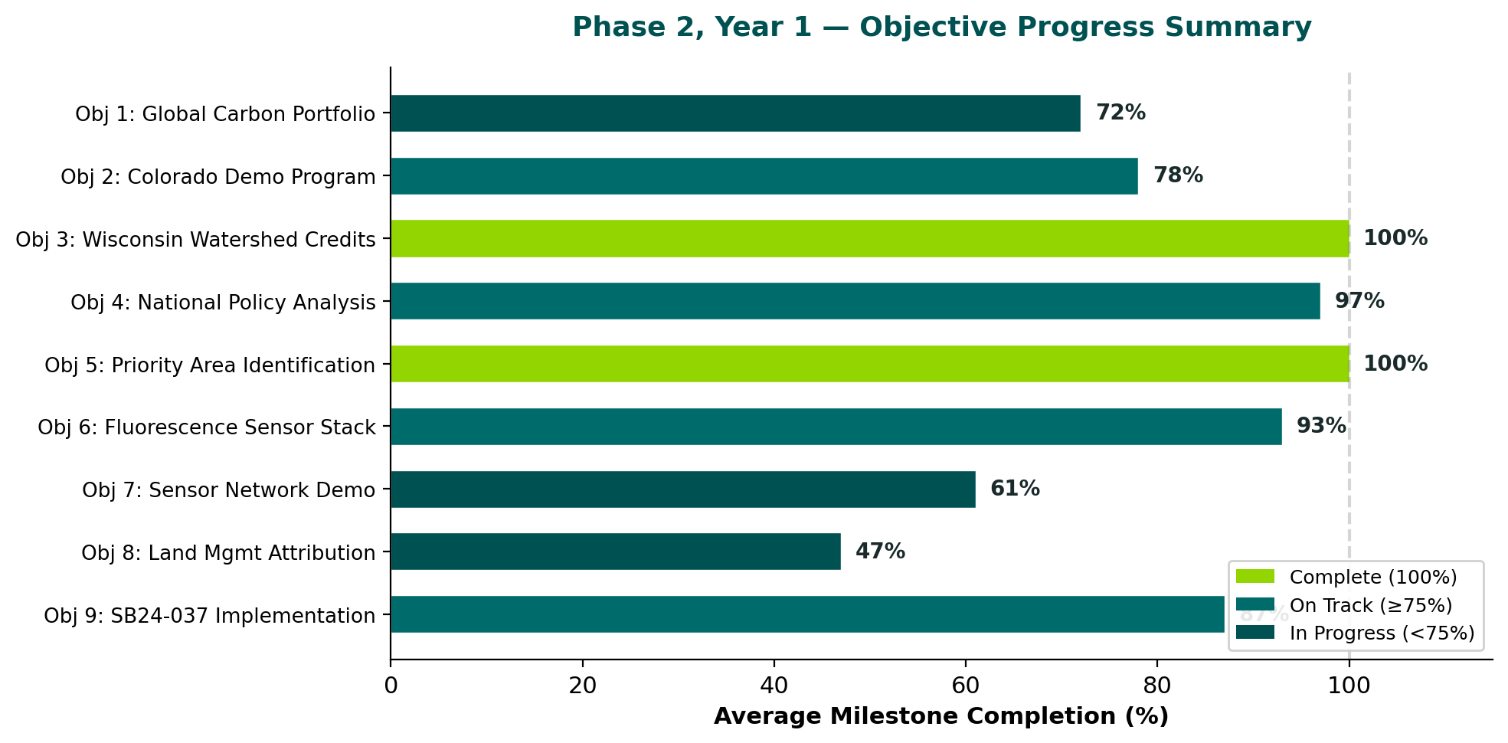
Figure 3. Phase 2, Year 1 objective completion summary across all milestones (as of March 15, 2026).
Across Phase 2 Year 1, progress has continued along all nine objectives. On the sensing and technology front (Objectives 6–8), the team built and tested the Lume v1.1 sensor hardware, collected more than 500 coincident field samples comparing sensors to lab E. coli measurements across eight installations, and developed machine-learning models achieving 70–80% categorical accuracy and 15–30% log error rates. Laboratory testing demonstrated consistent TLF detection through turbidity of 0–500 NTU. The global E. coli dataset has reached over 10 million observations with more than 8 million passing quality checks. A manuscript has been submitted reporting sub-ppb sensitivity and greater than 90% balanced accuracy on the Seine deployment.
On the carbon finance front (Objectives 1–3), the project has signed credit sales contracts totaling approximately $18M in projected revenue. Key milestones completed include Rwanda Letter of Authorization, Turkey PDD listing under Verra, first watershed carbon credit issuance under Regen Registry, and the Water Environment Federation’s purchase of 1,000 tonnes to offset WEFTEC. The team finalized approximately 100,000 credits from Water Mission in Tanzania. Louis Dreyfus Company has contracted interest in irrigation-based credits through VM0042. In Wisconsin, the Yahara WINS program achieved the first-ever verified watershed carbon credit issuance. Actual credit issuances to date include 7,665 credits from Amazi Meza Rwanda in 2024 and 33,911 credits in 2025, 12,384 credits from LifeStraw Kenya in 2026, and 24,143 credits from the Madison Wisconsin watershed program in 2026. Projected issuances across the full portfolio—spanning Rwanda, Kenya, DRC, Burundi, Madagascar, Tanzania, Turkey, and Wisconsin—are expected to exceed 500,000 credits annually by 2030.
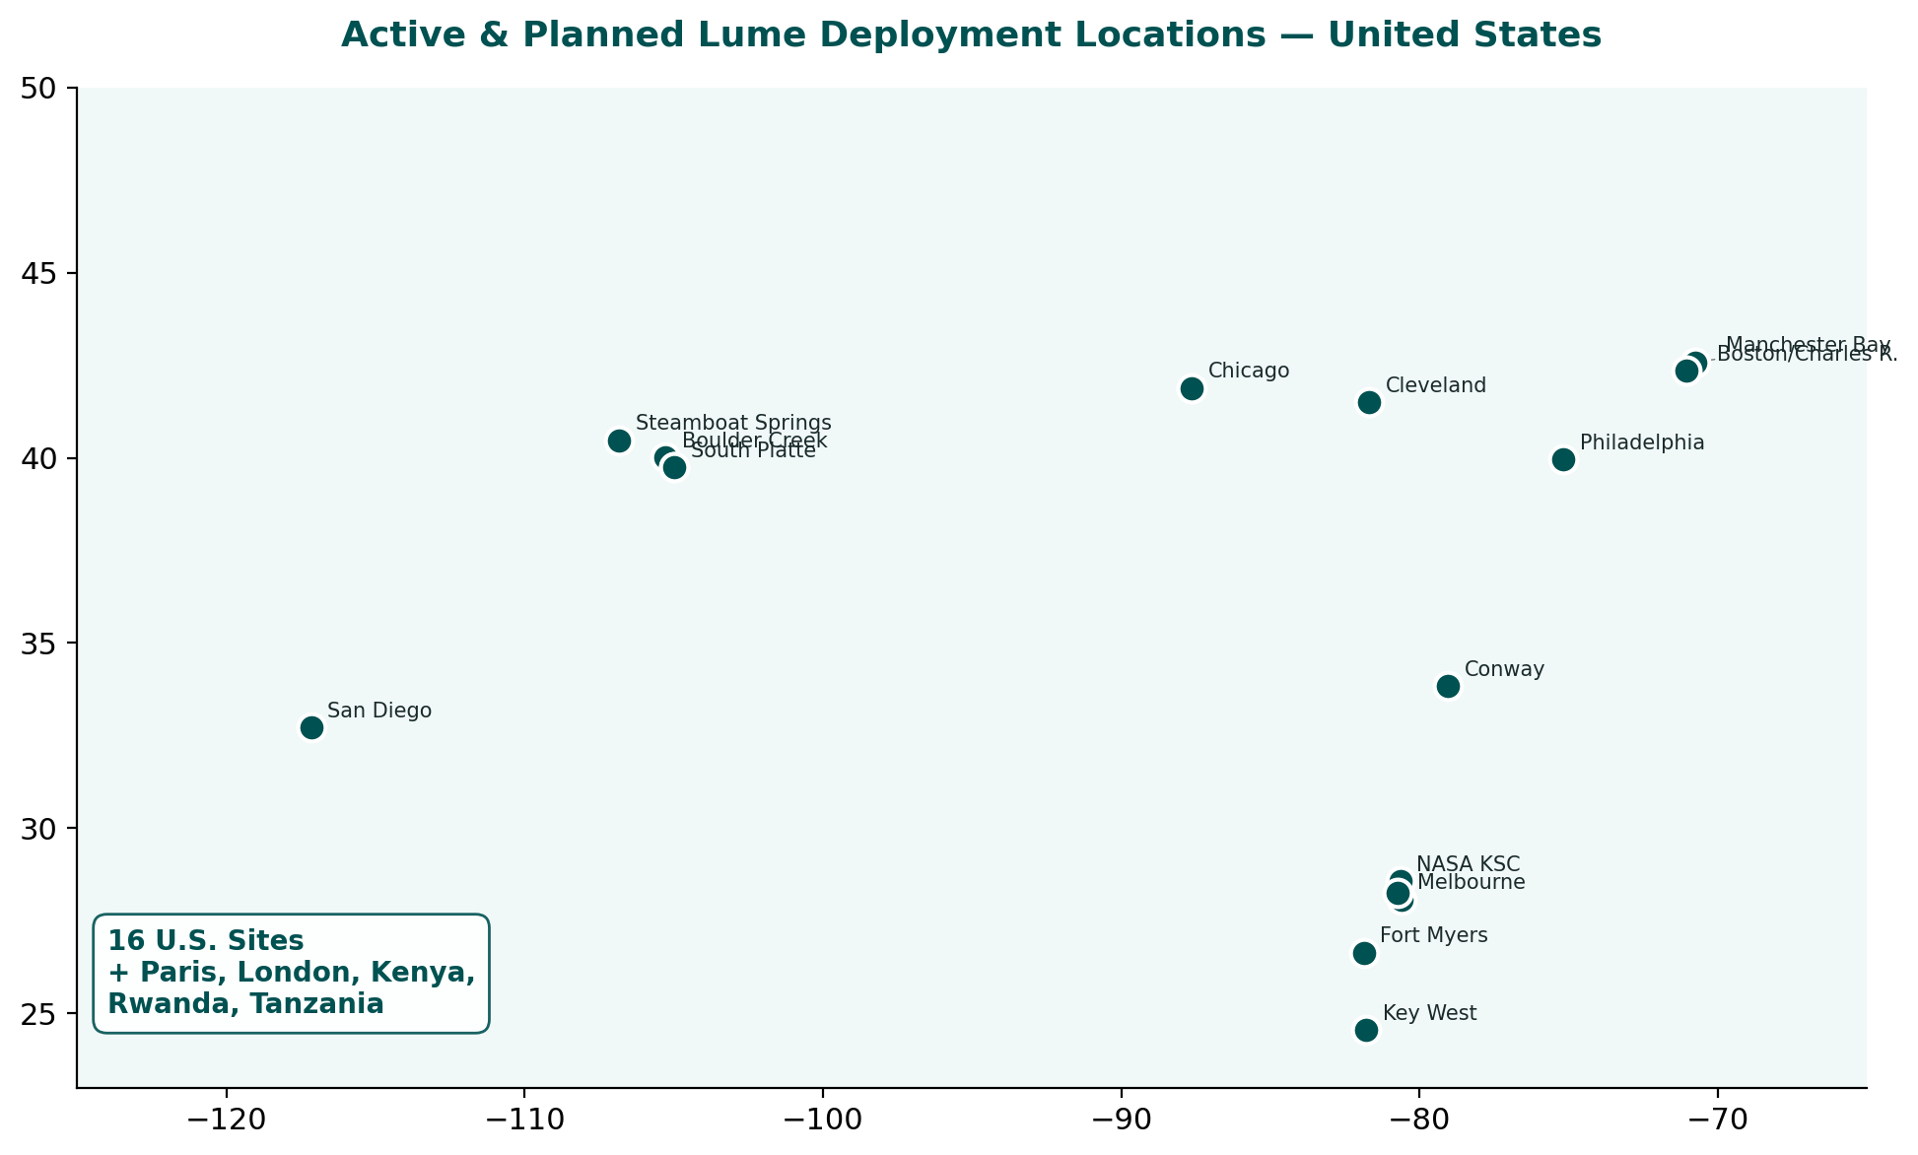
Figure 4. Active and planned Lume sensor deployment locations across the United States (16 sites), with additional international deployments in Paris, London, Kenya, Rwanda, and Tanzania.
On deployment and market traction, four 2026 contracts are moving into implementation: Boulder Creek (City of Boulder, CO), Manchester Bay (Manchester by the Sea, MA), Cerebulb (Fort Myers, FL), and Marine Resources Council (Melbourne, FL). The U.S. Air Force has confirmed intent to purchase 1–2 Lume v1.2 devices, with USAF personnel visiting the Virridy lab in April 2026. Channel partner discussions continue with Suez (Veolia) and OTT Hydromet. Deployment discussions are ongoing for more than eight additional locations including Chicago, Cleveland, Philadelphia, the Charles River, Paris, and several Florida sites. The Lume’s only direct competitor in TLF-based E. coli estimation is Proteus Instruments (UK), with estimated annual revenue of approximately $561,000 and unit pricing of $10,000–$30,000. Virridy’s Lume has already displaced Proteus on the H2NOW real-time water quality platform in Chicago, operated by Current (an NSF Engine recipient). The broader water quality sensor market is experiencing significant consolidation, with In-Situ Inc. acquired by Veralto Corporation for $435 million and Chelsea Technologies’ parent Covelya Group being acquired by Kraken Robotics for $615 million, underscoring the commercial value of environmental sensing platforms. Virridy is currently negotiating a strategic partnership with Veralto Corporation, which in addition to In-Situ owns Hach and OTT HydroMet, representing a potential channel to Veralto's global distribution network and installed base across water quality monitoring markets.
On the policy front (Objectives 4, 5, 9), state legislation SB24-037 was enacted in Colorado enabling watershed pilot programs. CDPHE approved three regional pilots and a three-year implementation timeline. The comparative analysis of national water quality trading best practices is 95% complete. One discharger is advancing toward pilot implementation. National engagement continues through the Aspen National Water Strategy and the Walton-backed Resilience Accelerator.
Risk Profile and Mitigation
Risk | Status | Mitigation
Manufacturing delays/tariffs | Resolved | Lume v1.2 received and in testing
Cl-A/FDOM market competition | Monitoring | Focus on TLF; exploring PFAS sensing with USAF
USDA RCPP not awarded | Pivoted | Direct implementation via Netafim Turkey and Mexico
Partner sensor data tracking | In progress | Structured tracking processes being designed
Pooled portfolio credit demand | Uncertain | Testing buyer interest by credit type
Plans for Phase 2, Year 2 (emphasis on acceleration and deliverables)
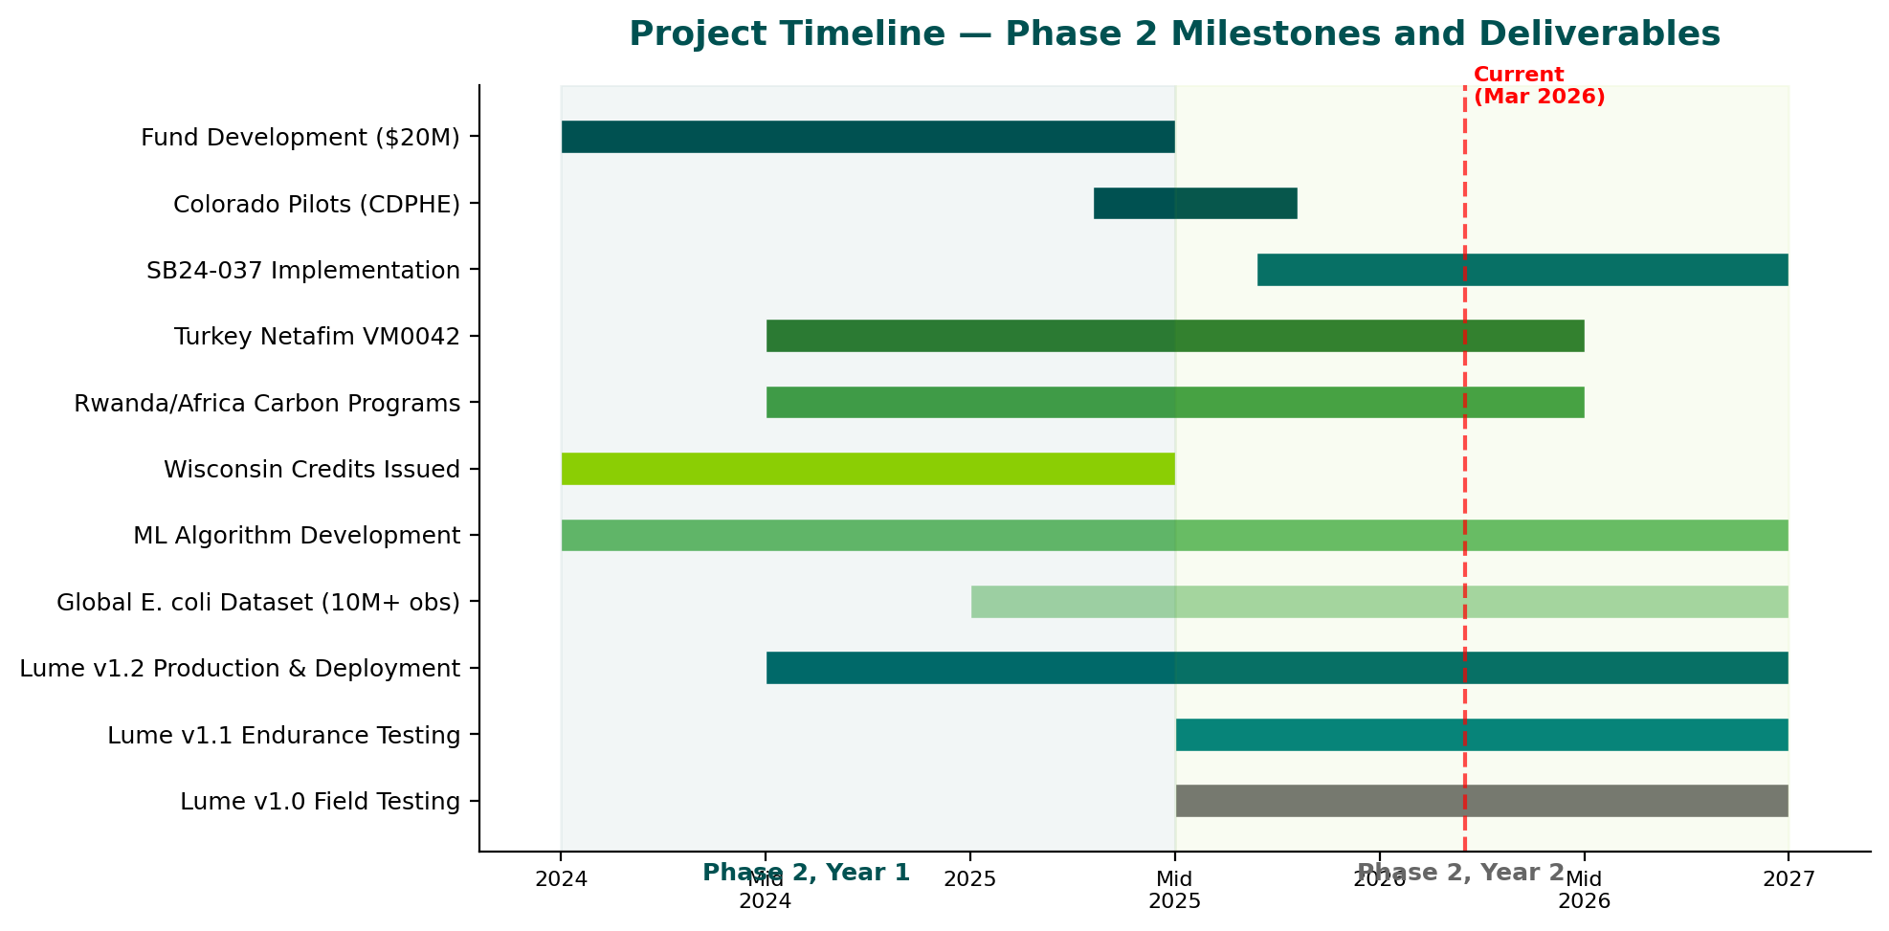
Figure 5. Project timeline showing Phase 2 milestones and deliverables across sensing, carbon finance, and policy tracks. Red dashed line indicates current date.
Phase 2 Year 2 will focus on acceleration along three coupled tracks: (1) scaling Lume v1.2 deployments and data pipelines to improve site-generalizable E. coli models and operationalize partner workflows; (2) scaling carbon finance execution, including completing the Water Mission Tanzania purchase, Madagascar Gold Standard auditing, and VM0042 farmer recruitment in Turkey and Mexico targeting over 10,000 hectares; and (3) translating SB24-037 policy work into operational compliance pathways, moving from “pilots in concept” to “pilots in motion” with at least one discharger advancing through CDPHE review during 2026.
Near-term priorities include completing USAF Lume modifications for the April lab visit, advancing anchor investors for the $20M fund with Total Impact Capital, deploying Lumes on the South Platte, Cherry Creek, and Indian River Lagoon, sustaining Millennium Water Alliance technical working group leadership, and continuing follow-up with over 100 Lume and carbon-finance partner prospects.

Budget and Financial Overview
The NSF Convergence Accelerator award is structured as a deliverables-based contract, under which Virridy invoices $185,000 per month against monthly progress reports documenting milestone completion across all nine objectives. This structure directly ties federal funding to demonstrated progress in sensing, carbon finance, and policy deliverables.
Major subcontracts support two key academic and implementation partners. The University of Colorado Boulder is subcontracted at $200,000 in Year 1, $200,000 in Year 2, and $100,000 in Year 3, providing research expertise in environmental engineering, watershed science, and sensor validation. Open Current is subcontracted under the same structure ($200,000 Year 1, $200,000 Year 2, $100,000 Year 3), supporting deployment operations, partner engagement, and implementation activities. The remaining budget supports Virridy personnel, hardware development and manufacturing, field operations, carbon program development, and policy engagement.

The financial structure is complemented by non-NSF capital including private investment ($8.5M equity led by Accord Capital and Mortenson Construction), advance credit pre-purchases ($2M from Mortenson), and philanthropic grants (Moore Foundation, Walton Family Foundation). From a commercialization standpoint, the project is now coupled to revenue execution pathways including executed multi-year credit sales contracts totaling approximately $18M in gross revenue, initial watershed carbon credit issuance through Regen Registry, and expanding Lume deployment contracts. Budget reallocations for Year 2 are primarily associated with scaling deployments, expanding MRV capacity, and selectively investing in sensor roadmap adjustments.

Sustainability Plan
Long-term sustainability is based on a hybrid research–commercialization model. The lead organization operates as a for-profit entity with dual revenue engines: water-quality sensing and analytics services (Lume deployments at $200/month per site) and carbon-credit generation and sales under Gold Standard, Verra VCS, and Regen Registry methodologies. Near-term sustainability is strengthened by executed credit sales contracts totaling approximately $18M, expanding Lume deployment contracts, and USAF procurement interest. The global water-quality sensor market was valued at $5.7 billion in 2024 and is projected to reach $9.1 billion by 2030 (8.1% CAGR). Virridy is negotiating a strategic partnership with Veralto Corporation, owner of In-Situ, Hach, and OTT HydroMet, which would provide access to established global distribution channels.
The platform’s cost-effectiveness is further validated by comparison with incumbent laboratory methods. IDEXX Laboratories’ water testing segment generates $201 million in annual revenue from culture-based methods requiring $8–30 per test and 18–24 hours for results. The Lume’s continuous monitoring at $200 per month per site provides orders-of-magnitude more data points at comparable total cost, positioning it as a screening complement that can reduce laboratory testing frequency while improving contamination detection speed.
Scalability derives from three reinforcing mechanisms: policy frameworks create regulatory pathways for watershed programs, monitoring technologies provide credible measurement and verification of outcomes, and carbon markets supply financing incentives. Together these create a self-reinforcing system enabling sustained expansion without reliance on continued grant funding. The project’s current trajectory—operating across 9 countries with projections of 5 million people reached and over 3 million credits generated by 2030—demonstrates that this model is already scaling beyond the initial research context.

